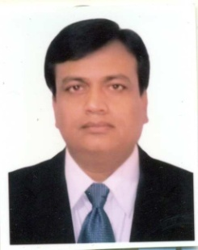
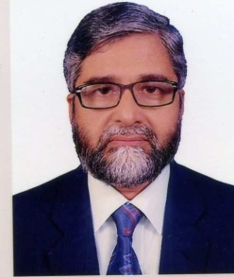
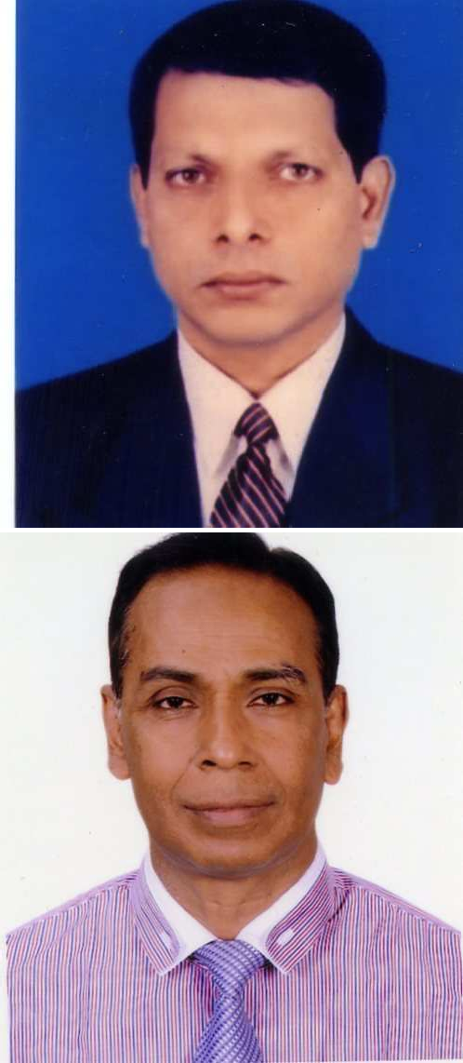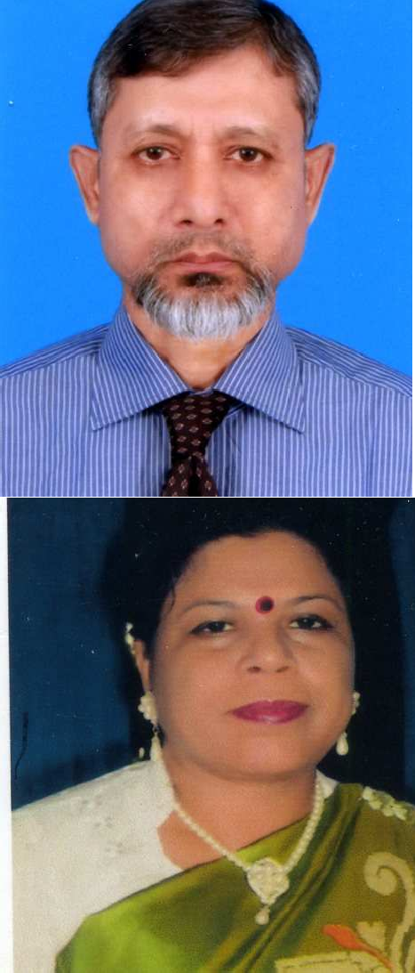List of DAM Officers:

Sl. | Photo | Name of Officer & designation | Phone, E-mail & Mobile No.
01 |  | Md. Mahbob Ahmed Joint Secretary  Director General | Phone: 9114310 (Off)  8120300 (Res.)  01511610610 (Mobile)  FAX: 9139385  E-mail: director@dam.gov.bd
02 |  | Omar Faruk Chowdhury Chief (R & D) | Phone: 9114093 (Off)  58154317 (Res.)  01720014872 (Mobile)  E-mail: chief@dam.gov.bd
03. |  | Md. Abdur Rashid Deputy Director (MIS) | Phone: 9115997 (Off)  8034295 (Res.)  01552336164 (Mobile)  E-mail: dd_mis@dam.gov.bd
04. |  | Shahnaz Begum Neena Deputy Secretary  Deputy Director (RETC) | Phone: 9140995 (Off)  9612099 (Res.)  01552322471 (Mobile)  E-mail: neenashahnaz@gmail.com
05. |  | Anarul Kabir Deputy Chief (P&D) | Phone: 9114822 (Off)  9144408 (Res.)  01914643758 (Mobile)  E-mail: dc_p@dam.gov.bd
06. |  | Dewan Ashraful Hossain Deputy Director | Phone: 071-63118 (Off)  9102215 (Res.)  01727307064 (Mobile)  E-mail: dewanahossain@gmail.com

07. |  | Dr. Fatema Wadud  Deputy Director (SHOGORIK) | Phone: 9123671 (Off)  9123823 (Res.)  01711527865 (Mobile)  E-mail: dd_shogorik@dam.gov.bd
08. |  | Mohammad Reza Ahmed Khan Assistant Chief (Research-2) | Phone: 9116776 (Off)  - (Res.)  01818170059 (Mobile)  E-mail: ac_research1@dam.gov.bd
09. |  | Md. Jahangir Hossen Assistant Chief (Research-1) | Phone: 9114605 (Off)  9335497 (Res.)  01552376469 (Mobile)  E-mail: ac_research1@dam.gov.bd
10. |  | Md. Fazlur Rahman Assistant Chief (Research-4) | Phone: 9114605 (Off)  8022688 (Res.)  0172350166 (Mobile)  E-mail: ac_research4@dam.gov.bd
11. |  | Anowarul Haque  Zonal Manager (SHOGORIK) | Phone: 0521-55634 (Off)  - (Res.)  01912026436 (Mobile)  E-mail: zmrangpur@dam.gov.bd
12. |  | Md. Mozibar Rahman  Assistant Director (Training and Coordination) | Phone: 9110260 (Off)  - (Res.)  01552422900 (Mobile)  E-mail: mrbacchu72@yahoo.com
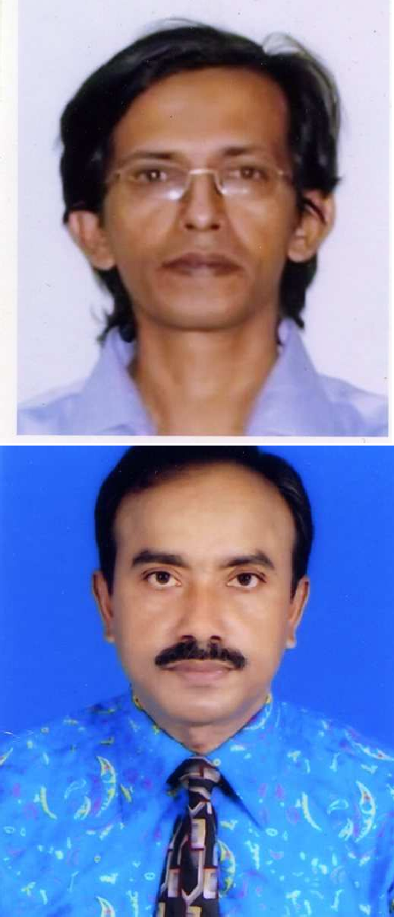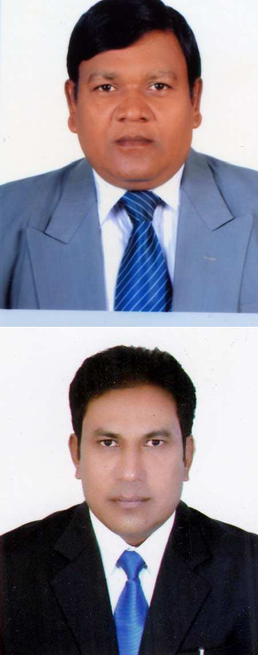

13. |  | S.M. Syed Hasan  Assistant Director (Admin) | Phone: 9114765 (Off)  - (Res.)  01710871338 (Mobile)  E-mail: ad_admn@dam.gov.bd
14. |  | Nasrin Sultana Assitant Director | Phone: 9116894 (Off)  9614256 (Res.)  01730074096 (Mobile)  E-mail: ro_research3@dam.gov.bd
15. |  | Touhid Md. Rashed Khan Assistant Director | Phone: 9116170 (Off)  - (Res.)  01556318268 (Mobile)  E-mail: rkshahu@gmail.com
16. |  | Nikhil Chandra Day Research Officer (P&D) | Phone: 9116170 (Off)  - (Res.)  0171435623 (Mobile)  E-mail: dey.nikhil@ymail.com
17. |  | Md. Shahidul Islam Assistant Director | Phone: 9123671 (Off)  - (Res.)  01912283867 (Mobile)  E-mail: shanid.bc.bd@gmail.com
18. |  | Sultanan Nasira Assistant Director | Phone: 9123671 (Off)  - (Res.)  01914390262 (Mobile)  E-mail: ad_shogorik2@dam.gov.bd
19. |  | Most. Israt Jahan  Assistant Director (Research-5) | Phone: 9116894 (Off)  - (Res.)  01711733251 (Mobile)  E-mail: isratjahan1974@yahoo.com
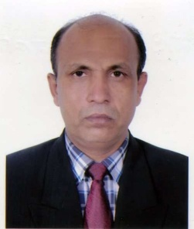
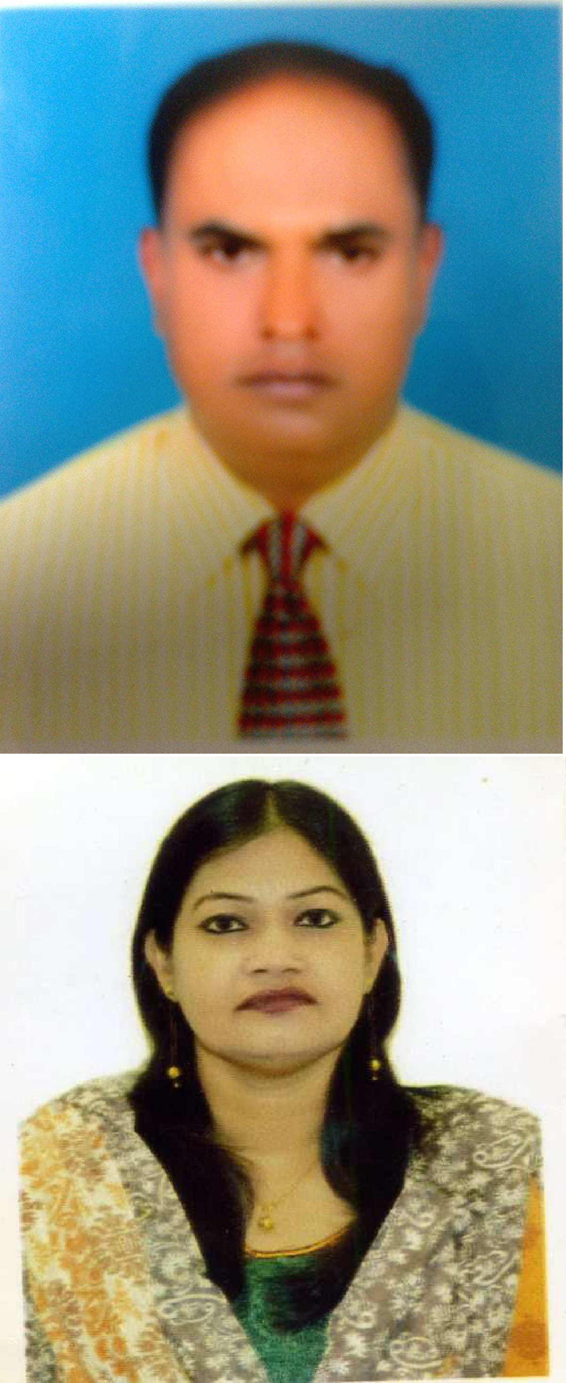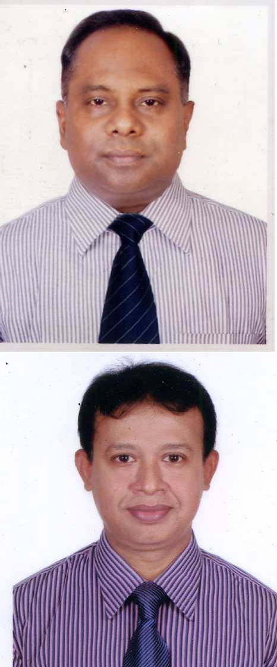

- 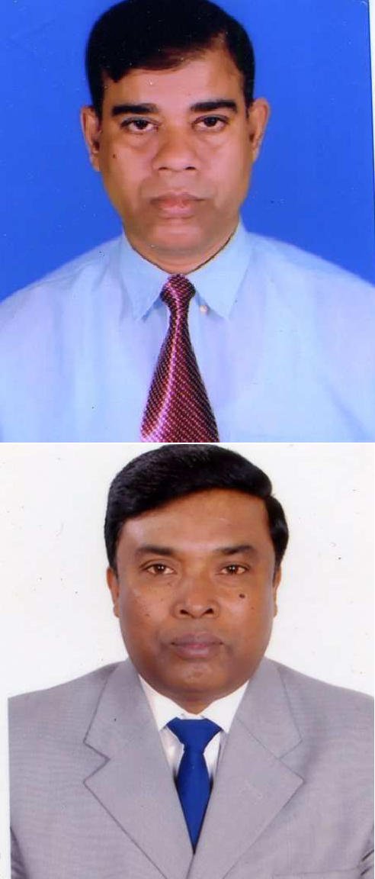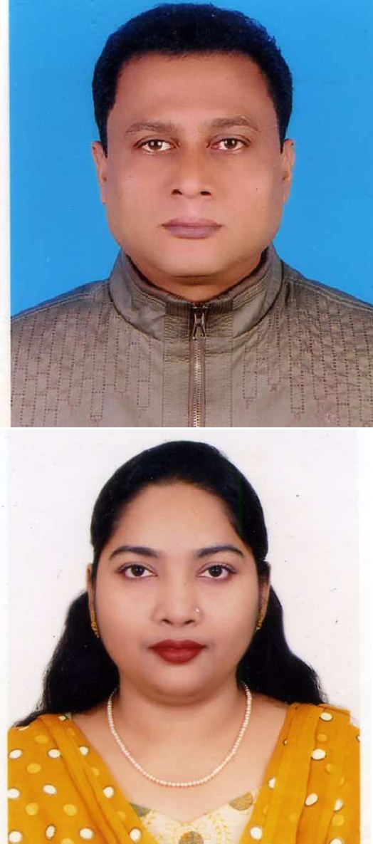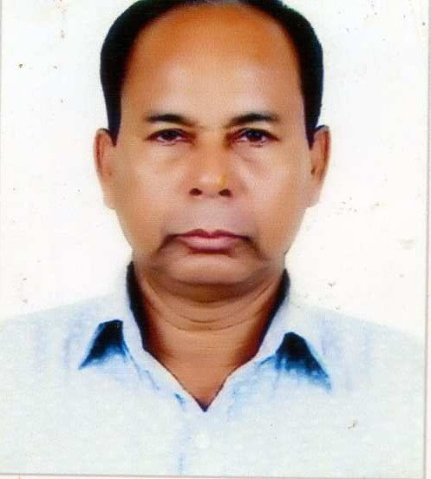GM Mohiuddin
Assistant Director (MI)
Phone: 9116894 (Off)
  - (Res.)
01711185990 (Mobile)
E-mail: adfurrajdam@gmail.com

- Md. Abdur Razzak Accounts Officer
Phone: 9116169 (Off)
  - (Res.)
01711185990 (Mobile)
E-mail: abdurrajdam@gmail.com

- Nazgir Ahmed
Accounts Officer
Phone: 9114765 (Off)
8399574 (Res.)
01918194124 (Mobile)
E-mail: nazgir@dam.gov.bd

- Kazi Fauzia Rahman Marketing Officer
Phone: 9114765 (Off)
  - (Res.) 01712195664 (Mobile)
E-mail: kazifauziar@gmail.com

- Chandan Kanti das Marketing Officer

Phone: 9116170 (Off)
  - (Res.) 01552384471 (Mobile)
E-mail: kowkhali_das@yahoo.com

- A.B.M. Mizanul Hoq Marketing Investigator
Phone: 9116894 (Off)
  - (Res.) 01913557173 (Mobile)
E-mail: mizan_hoq168@yahoo.com

- Md. Idris Ali
Marketing Investigator
Phone: 9116170 (Off)
  - (Res.)
01912220038 (Mobile)
E-mail: idrisalidam@gmail.com

